PROGRAM
import cv2

img = cv2.imread("rotation_image.png")

if img is None:
print("Image not found! Check the image name.")
else:
rotated = cv2.rotate(img, cv2.ROTATE_90_COUNTERCLOCKWISE)

cv2.imshow("Original Image", img)
cv2.imshow("Rotated Image - 270 Degrees Clockwise", rotated)

cv2.imwrite("rotated_270.png", rotated)

cv2.waitKey(0)
cv2.destroyAllWindows()

print("270-degree rotated image saved successfully!")

OUTPUT
The original image and the image rotated by 270 degrees clockwise are displayed. The rotated image is saved as rotated_270.png.

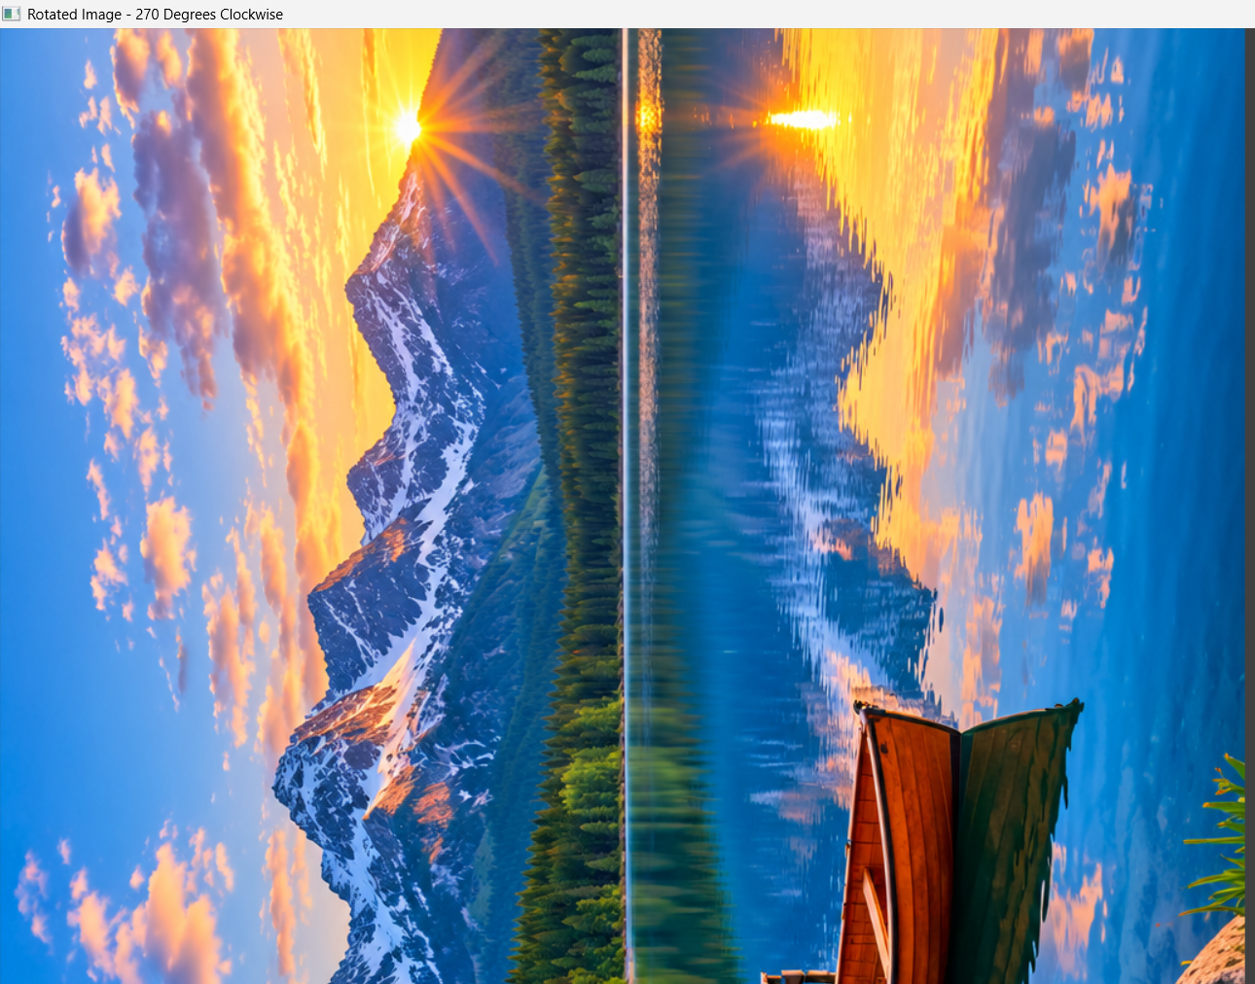

RESULT
Thus, the given image was successfully rotated by 270 degrees clockwise using Python and OpenCV.

